- 单项选择。
( )1.——Is this your pen?
——No, .
A.it isn’t B.it is C.this isn’t
( 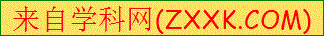 )2.That my pencil case.
A.am B.are C.is
( )3.——Don’t in class, Liu Tao.
——I’m sorry.
A.talk B.talks C.talking
( )4.——Mike, is that rubber?[来源:学*科*网]
——Yes, it is.
A.an B.you C.your[来源:Zxxk.Com]
( )5.——What’s over there?
——It’s a crayon.
A.this B.that C.the

